PROJECT REPORT
Implement Client Script & UI Policy (Incident)
ServiceNow Course

1. INTRODUCTION

1.1 Project Overview
This project demonstrates configuration-based client-side controls on the ServiceNow Incident table. The implementation uses UI Policies, UI Policy Actions, and Client Scripts to improve the quality and consistency of Incident records. The controls are intended to guide users during Incident creation and update by changing field behavior according to defined Incident conditions.

1.2 Purpose
The purpose of the project is to show how ServiceNow can be configured to enforce appropriate Incident form behavior without relying only on manual checking. UI Policies and UI Policy Actions are used for mandatory, visible, and read-only behavior, while Client Scripts are documented as a mechanism for client-side checking, dynamic processing, user feedback, and submission-related validation.
- ServiceNow Incident Management provides the working context for the project.
- UI Policies define conditions under which Incident form fields change behavior.
- UI Policy Actions apply mandatory, visible, and read-only settings to fields.
- Client Scripts support client-side form behavior and validation when configured for an appropriate event.
- GlideForm (g_form) is the ServiceNow client-side form API used by Client Scripts; no programming implementation is included in this report.

2. IDEATION PHASE

2.1 Problem Statement
Incident records require consistent and accurate data entry for effective triage, routing, reporting, SLA management, and resolution. When users enter information manually without sufficient dynamic controls, important information may be missing or inconsistent. This can affect the quality of Incident management. The project addresses this problem through conditional form behavior and configuration-based client-side validation.
- Missing Incident information
- Inconsistent data entry
- Incorrect Incident details
- Reduced reporting accuracy
- Routing difficulties
- Potential SLA-related data problems

2.2 Empathy Map Canvas
Area | Incident User Perspective
Says | The form should clearly indicate which information is required for important Incidents.
Thinks | I need to know what information must be completed before I submit the Incident.
Does | Creates or updates Incident records and enters information in the available fields.
Feels | May become uncertain when requirements are not visible or validation happens only after submission.
Pain Points | Missing fields, inconsistent entries, unclear requirements, and unnecessary rework.
Needs | Clear field behavior, immediate feedback, and consistent Incident data-entry rules.

2.3 Brainstorming
- Use a UI Policy to apply conditional field behavior on the Incident form.
- Use UI Policy Actions to make Assignment Group mandatory for high-impact/critical Incidents.
- Use UI Policy Actions to control the read-only behavior of Urgency.
- Use Client Script configuration for client-side Incident form behavior and validation.
- Provide user feedback when required Incident information is missing.
- Keep the solution focused on the Incident table and avoid unnecessary advanced ServiceNow concepts.

3. REQUIREMENT ANALYSIS

3.1 Customer Journey map
Stage | User Activity | System Behavior | Expected Experience
Open Incident | User opens the Incident form. | Incident form loads with configured fields. | User can begin Incident entry.
Enter Details | User provides Incident information. | Configured UI controls respond to relevant conditions. | Required information is easier to identify.
High/Critical Condition | User selects the applicable priority/impact condition. | UI Policy Actions apply configured field behavior. | Important fields become appropriately controlled.
Validation | User attempts to proceed or submit. | Client-side validation checks the configured requirement. | User receives appropriate feedback when information is missing.
Correction | User completes missing information. | Form behavior updates according to configured conditions. | User can proceed with a more complete record.
Record Submission | User submits the Incident. | Valid information is allowed to proceed. | Incident record is created or updated with improved consistency.

3.2 Solution Requirement
Functional requirements:
- The system shall allow users to create Incident records.
- The system shall dynamically control Incident fields using UI Policies.
- The system shall make specified fields mandatory when defined conditions are satisfied.
- The system shall control field visibility where required.
- The system shall control read-only behavior where required.
- The system shall support Incident data validation using Client Scripts.
- The system shall provide appropriate user feedback when required information is missing.
- The system shall improve consistency of Incident records.
Non-functional requirements:
Requirement | Description
Usability | The Incident form should clearly communicate required and restricted fields.
Reliability | Configured rules should consistently apply when their conditions are met.
Maintainability | Rules should be understandable and manageable by ServiceNow administrators.
Performance | Client-side controls should respond without unnecessary processing.
Data Consistency | Important Incident information should follow defined entry requirements.
Security | Client-side controls should complement, not replace, appropriate server-side controls.
Ease of Configuration | Rules should be configurable using standard ServiceNow form configuration features.

3.3 Data Flow Diagram
The logical data flow shows how a user interacts with the Incident form and how the configured controls support validation before a valid Incident record is submitted.
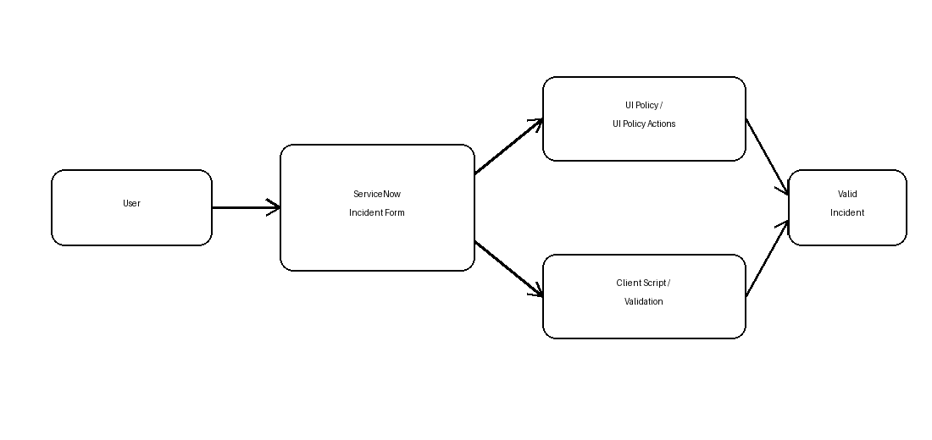
Figure: Data Flow Diagram for Incident Form Controls

3.4 Technology Stack
Technology / Tool | Purpose
ServiceNow Platform | Platform used to configure and manage the Incident solution.
Incident Management | Provides the Incident table and form used by the project.
UI Policies | Define conditional client-side field behavior.
UI Policy Actions | Set field properties such as mandatory, visible, and read-only.
Client Scripts | Support client-side checking, dynamic form processing, feedback, and validation.
GlideForm (g_form) | ServiceNow client-side form API available to Client Scripts; no code is included in this report.
Client-side Form Behavior | Provides responsive behavior while the user interacts with the Incident form.

4. PROJECT DESIGN

4.1 Problem Solution Fit
Problem | Configured Solution | Expected Benefit
Missing required Incident information | Conditional mandatory field control | Improves completeness of important records.
Users are unsure which fields require attention | Visible and mandatory UI behavior | Provides clearer form guidance.
Important fields may be changed incorrectly | Read-only field behavior where appropriate | Reduces unintended changes.
Validation depends on manual checking | Client-side validation concept | Provides timely user feedback.
Inconsistent Incident entry | Standardized configuration rules | Improves consistency across records.

4.2 Proposed Solution
The proposed solution uses the ServiceNow Incident table with one realistic UI Policy and related UI Policy Actions, supported by Client Script configurations. For a high-impact or critical Incident condition, Assignment Group and Short Description are treated as important required information. Appropriate fields can be controlled for visibility or read-only behavior, while client-side validation supports checking of required information before submission.
Incident scenario:
Configuration Item | Project Configuration
Table | Incident [incident]
UI Policy | High Impact Control
Condition | Incident Impact is High / applicable high-impact condition
Active | True
Reverse if false | True
On Load | Enabled where required so the form reflects the condition when loaded
Assignment Group | Mandatory when the condition is satisfied
Short Description | Mandatory for critical/high-priority Incident handling
Urgency | Read-only under the demonstrated high-impact UI Policy Action
Client Script | Configuration-level client-side behavior and validation support

4.3 Solution Architecture
The solution follows a simple client-side form-control flow. UI Policies determine declarative field behavior, while Client Scripts support client-side processing and validation. Both are configured for the Incident form and are intended to work together rather than serve as interchangeable features.
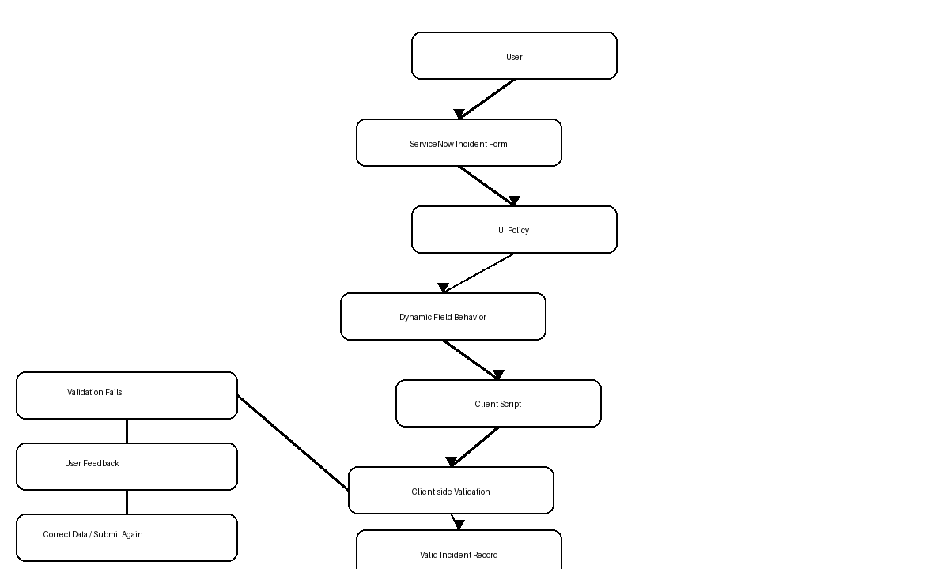
Figure: Solution Architecture and Validation Flow

5. PROJECT PLANNING & SCHEDULING

5.1 Project Planning
Phase | Planned Activity | Output
1. Requirement Analysis | Understand Incident data-quality problem and define project scope. | Project requirements and scenario
2. UI Policy Design | Define condition and field behavior for high-impact Incidents. | UI Policy and UI Policy Action plan
3. Client Script Design | Define configuration-level client-side validation and behavior. | Client Script configuration plan
4. Configuration | Configure Incident form, UI Policy, UI Policy Actions, and Client Scripts. | Configured ServiceNow records
5. Testing | Check normal and high-impact conditions and validation scenarios. | Test evidence / results to be verified
6. Documentation & Demo | Capture configuration evidence and prepare the project report/demo. | Final report and demo material

6. FUNCTIONAL AND PERFORMANCE TESTING

6.1 Performance Testing
Testing focuses on functional behavior of the Incident form and responsiveness of the configured client-side controls. The following results are intentionally marked as to be verified because the supplied evidence shows configuration screens rather than independently documented runtime test results.
Test Case ID | Test Scenario | Input / Condition | Expected Result | Actual Result | Status
TC-01 | Normal-priority Incident | Normal priority/impact condition | Standard Incident form behavior remains available. | To be verified | To be verified
TC-02 | Critical/high-priority Incident | High/critical condition is selected | Configured mandatory/read-only behavior is applied. | To be verified | To be verified
TC-03 | Required field empty | Required Incident field is left blank | User receives appropriate validation feedback. | To be verified | To be verified
TC-04 | Required field populated | Required field contains valid information | Validation requirement is satisfied. | To be verified | To be verified
TC-05 | UI Policy condition satisfied | Condition evaluates as true | UI Policy Actions apply to configured fields. | To be verified | To be verified
TC-06 | UI Policy condition not satisfied | Condition evaluates as false | Reverse/normal field behavior is restored as configured. | To be verified | To be verified
TC-07 | Client Script validation condition | Configured validation condition occurs | Client-side validation provides appropriate feedback. | To be verified | To be verified
TC-08 | Valid Incident submission | All required information is provided | Incident can proceed for submission. | To be verified | To be verified

7. RESULTS

7.1 Output Screenshots
The following figures use the ServiceNow configuration screenshots previously supplied for this project. They provide configuration evidence for the UI Policy Actions and Client Script records. Script-editor areas have been excluded from the Client Script figures so that the report remains configuration-focused.
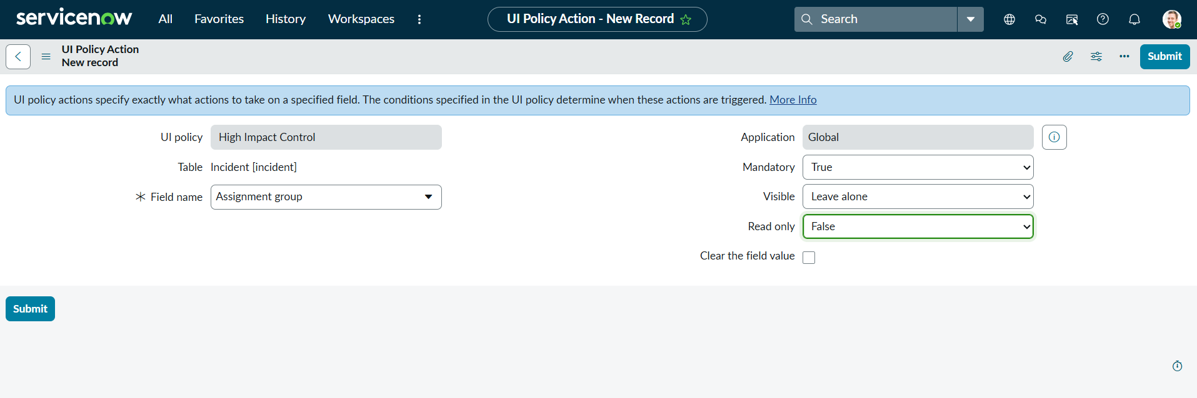
Figure 1: Assignment Group UI Policy Action
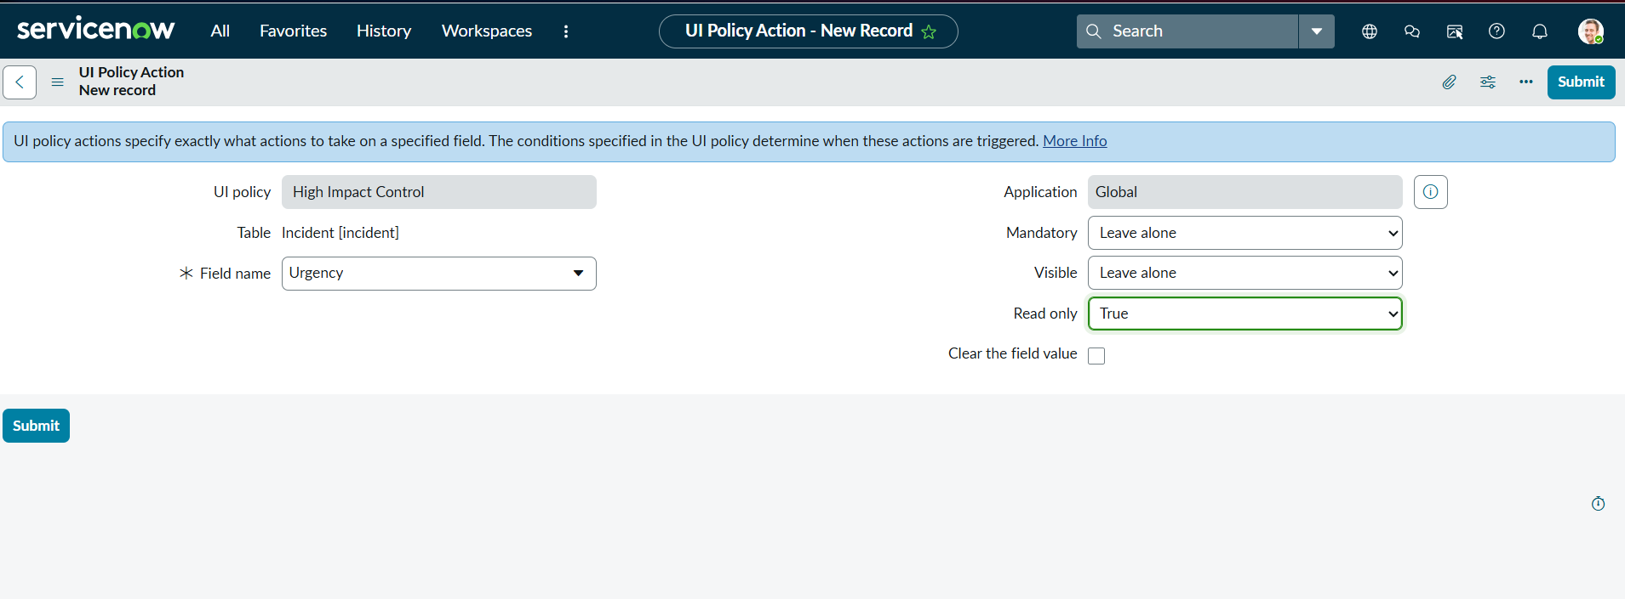
Figure 2: Urgency UI Policy Action
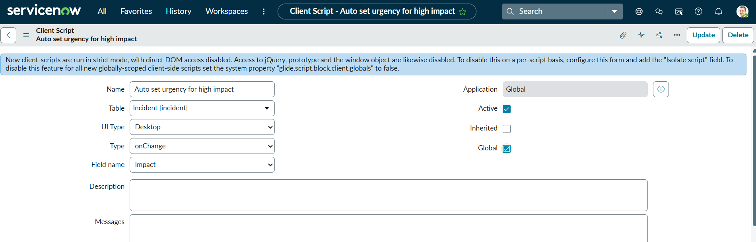
Figure 3: Auto Set Urgency Client Script Configuration
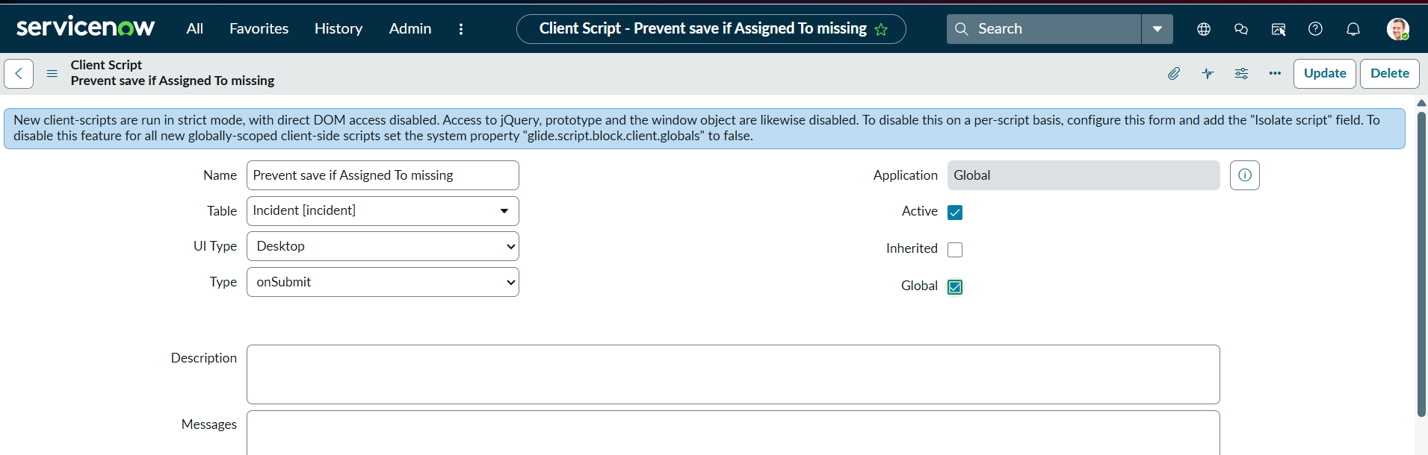
Figure 4: Prevent Save Client Script Configuration
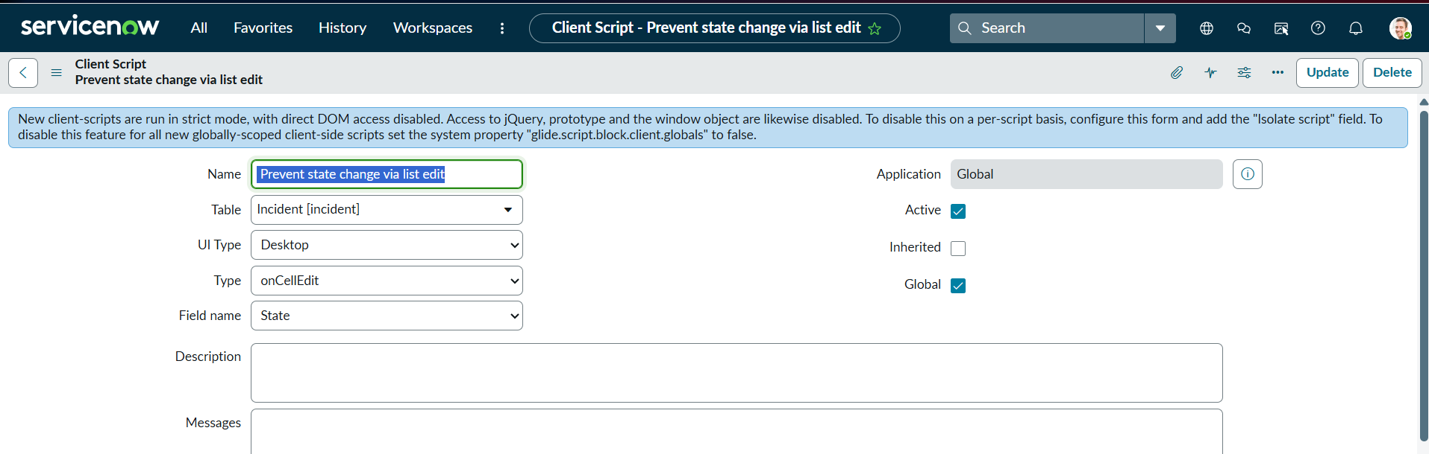
Figure 5: Prevent State Change via List Edit

8. ADVANTAGES & DISADVANTAGES
Advantages
- Improves Incident data quality.
- Reduces incomplete records.
- Provides immediate user feedback.
- Reduces manual validation effort.
- Improves consistency of Incident records.
- Supports better Incident Management.
- Makes the Incident form more user-friendly.
- Reduces unnecessary data-entry errors.
Disadvantages
- Client-side controls depend on correct ServiceNow configuration.
- Client-side validation should not replace appropriate server-side controls where required.
- Changes to field names or business requirements may require configuration updates.
- Client Scripts primarily control behavior on the client side.
- Behavior depends on the conditions configured in the UI Policy and Client Script.

9. CONCLUSION
The Implement Client Script & UI Policy (Incident) project demonstrates how ServiceNow configuration features can be used to improve Incident form behavior and data quality. UI Policies and UI Policy Actions provide conditional control over mandatory, visible, and read-only field properties. Client Scripts provide a client-side mechanism for checking information, supporting dynamic form processing, giving user feedback, and performing submission-related validation. GlideForm is the ServiceNow client-side form API available to Client Scripts. Together, these features can make Incident entry more consistent and easier for users while keeping the solution focused on standard ServiceNow capabilities.

10. FUTURE SCOPE
- Add additional Incident validation rules.
- Support more advanced Incident conditions.
- Introduce automated notifications where appropriate.
- Integrate the configuration with assignment rules.
- Add additional UI Policies for other Incident scenarios.
- Introduce server-side validation where appropriate.
- Improve reporting and monitoring of data-quality issues.
- Add further Incident data-quality controls as business requirements evolve.

11. APPENDIX
Source Code (if any)
No source-code listing is included in this report. The project is documented as a ServiceNow configuration-based implementation, and Client Scripts are described only from a functional and configuration perspective.
Dataset Link
Not applicable. The project operates on ServiceNow Incident records rather than a separate dataset.
GitHub & Project Demo Link
To be provided by the project team, if applicable.

References
- ServiceNow Documentation – Official product and platform documentation: https://www.servicenow.com/docs/
- ServiceNow Developers – Official developer documentation and learning resources: https://developer.servicenow.com/
- ServiceNow Developers – UI Policy Actions documentation and configuration guidance.
- ServiceNow documentation and developer resources for Client Scripts and GlideForm (g_form).

